Solution Architecture

|  |  |
| --- | --- |
| Date | 09 October 2022 |
| Team ID | IBMSI20220014416 |
| Project Name | Crude Oil Price Prediction |
| Maximum Marks | 4 Marks |

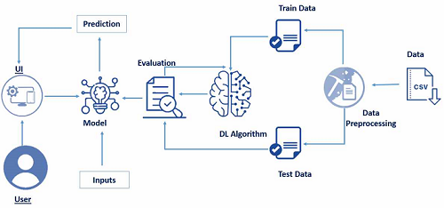

Our project is mainly based on machine learning and the model creation is based on the given conditions.

First, we should collect the relevant data by using, data collection is based on articulating the problem, defining the data to the given problem and gathering and combining the data from different sources and after collecting the data then, the data should be processed.

Secondly, after the data collection, the data should be processed by using formatting, cleaning and sampling the data. After processing the data, data transformation will be done.

Third, we will create the model based on learning model and validating the model and after validating the model we will deploy it.